Tensor Flow

Tensors are the standard way of representing data in TensorFlow (deep learning).

Tensors are multidimensional arrays, an extension of two-dimensional tables (matrices) to data with higher dimension.

In TensorFlow, tensors are described as unit of dimensionality as Rank.

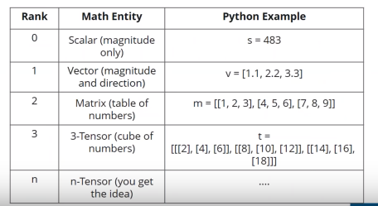

In TensorFlow you don’t ne to specify tensor data type.

What is TensorFlow

* TensorFlow is a Python library used to implement deep networks.
* In TensorFlow, computation is approached as a dataflow graph.
* TensorFlow works by first describing the model in the abstract then making it a reality.
* TensorFlow is a combination of Tensors and Flow ( i.e Tensor following in the computational Graph)
* TensorFlow core programs consists of two descrete sections.
  + Building a computation graph – here we just define the operations specify in the code
  + Running the graph creates a session, we can execute whole graph or part of the graph.
  + Graph Visualization: For visualizing the graph, we use tensorboard
  + Create object for class for writing summary